**Project Design Phase-II**

**Data Flow Diagram & User Stories**

**Data Flow Diagrams:**

A Data Flow Diagram (DFD) is a traditional visual representation of the information flows within a system. A neat and clear DFD can graphically depict the right amount of the system requirement. It shows how data enters and leaves the system, what changes the information, and where data is stored.

**Example:** [**(Simplified)**](https://developer.ibm.com/patterns/visualize-unstructured-text/)

**](https://developer.ibm.com/patterns/visualize-unstructured-text/)**

**DATA FLOW DIAGRAM:**

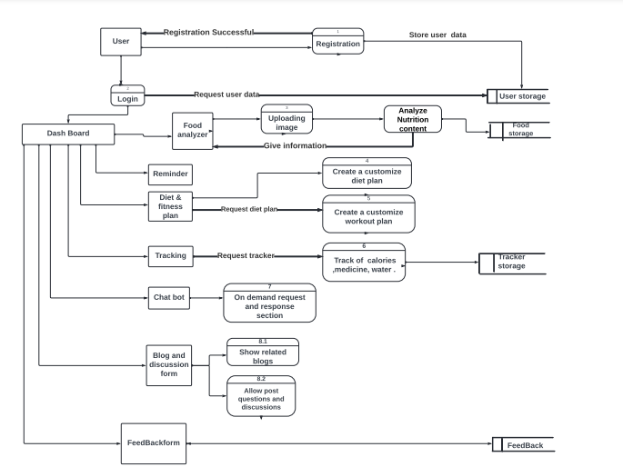

**User Stories:**

Use the below template to list all the user stories for the product.

| **User Type** | **Functional Requirement (Epic)** | **User Story Number** | **User Story / Task** | **Acceptance criteria** | **Priority** | **Release** |
| --- | --- | --- | --- | --- | --- | --- |
| Customer (Mobile user) | Registration | USN-1 | As a user, I can register for the application by entering my email and confirming my password. | I can access my account/dashboard | High | Sprint-1 |
|  |  | USN-2 | As a user, I will receive a confirmation email once I have registered for the application. | I can receive a confirmation email & click confirm | High | Sprint-1 |
|  |  | USN-3 | As a user, I can register for the application through Gmail. | I can automatically move on to the dashboard | Medium | Sprint-1 |
|  | Login | USN-4 | As a user, I can log into the application by entering my email & password. | I can access the dashboard | High | Sprint-1 |
|  |  | USN-5 | As a user, I can reset my password if I have forgotten my password | I can reset my password again. | Medium | Sprint-1 |
|  | My Account | USN-6 | As a user, I can view my personal information | I can view my details | High | Sprint-1 |
|  |  | USN-7 | As a user, I can edit my profile photo | I can view my profile photo | Medium | Sprint-1 |
|  |  | USN-8 | As a user, I can edit my email I will receive the confirmation email to my new email address | I can change my email address | Low | Sprint-1 |
|  |  | USN-9 | As a user, I can log out of the application from my account | I can exit my account | Medium | Sprint-1 |
| Customer (Web user) | Registration | USN-1 | As a user, I can register for the application by entering my email, and password, and confirming my password. | I can access my account/dashboard | High | Sprint-1 |
|  |  | USN-2 | As a user, I will receive a confirmation mail once I have registered for the application | I can receive a confirmation email & click confirm | High | Sprint-1 |
|  |  | USN-3 | As a user, I can register for the application through Gmail. | I can automatically move on to the dashboard | Medium | Sprint-1 |
|  | Login | USN-4 | As a user, I can log into the application by entering my email & password. | I can access the dashboard | High | Sprint-1 |
|  |  | USN-5 | As a user, I can reset my password if I have forgotten my password | I can reset my password again | Medium | Sprint-1 |
|  | My Account | USN-6 | As a user, I can view my personal information | I can view my details | High | Sprint-2 |
|  |  | USN-7 | As a user, I can edit my profile photo | I can view my profile photo | Medium | Sprint-2 |
|  |  | USN-8 | As a user, I can edit my email I will receive the confirmation email to my new email address | I can change my email address | Low | Sprint-2 |
|  |  | USN-9 | As a user, I can log out of the application from my account | I can exit my account | Medium | Sprint-1 |
| Customer Care Executive | Dashboard | USN-1 | As a user, I want to upload an image to get a food analyzing | I can get my nutritious chart | High | Sprint-2 |
|  |  | USN-2 | As a user, I can get my remainder | I can get my daily schedule | High | Sprint-3 |
|  |  | USN-3 | As a user, I can get diet and fitness plan | I can get my customized diet and workout plan | High | Sprint-3 |
|  |  | USN-4 | As a user, I can track my health | I can get my track of calories, medicine, and sleep. | High | Sprint-3 |
|  |  | USN-5 | As a user, I can have a commentary session | I can have question and answer section | Medium | Sprint-3 |
|  |  | USN-6 | As a user, I can read blogs and discussions about my query | I can have my related blogs and discussion about it | Medium | Sprint-4 |
| Administrator |  | USN-2 | As an admin, I have a feedback form from my customer | I can have my ups and down in my review session | High | Sprint-4 |
|  |  | USN-3 | As an admin, I can view how many customers use their app | I can view how users are interested in it | Medium | Sprint -4 |